
Zen Ethics and Compassionate Health Care
A day of meditation and teaching with Tenshin Reb Anderson, former abbot and senior dharma teacher at San Francisco Zen Centre
This workshop is for anyone who has issues around bodily and/or mental health 30th July 2013
From 10 am to 5pm
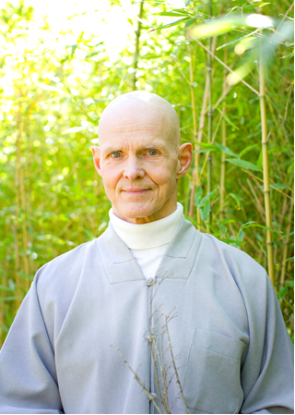
Where: Quaker Meeting House
Hampstead
London NW3 1DR
www.londonquakers.org

Enquiries:

E: reb2013london@dancingmountains.orguk

T: 07786 369682 (Frances Collins)

Cost: £50 waged / concessions on
request
Zen Ethics and Compassionate Health Care

On the Zen path there is a clear ethical responsibility to care for the health and happiness of all sentient beings. On this path one may practice three kinds of compassion; compassion towards beings, towards elements, and great objectless compassion. This retreat will offer teachings on these three modes of compassion.

Everyone is welcome to come to this zen meditation retreat and learn to listen and realize the perfect wisdom of the gentle buddhas; taught for the weal of the world, for heroic spirits intended. There will be periods of quiet sitting and walking meditation together with oral teachings and group discussions.

Please note lunch is NOT provided. The Hampstead area has a good choice of restaurants & recommendations can be given on request. Alternatively you can bring a lunch.
There will be a sale of Reb's books & talks will be recorded.
Certificate of attendance can be given on request for health professionals.
The venue has good disabled access with a drop off point in front of the building:-

Public Transport: Hampstead Tube Station (Northern line, Edgware branch).
Buses 210 or 268 to Whitestone Road.

